Computing Coursework

Samuel Young

<candidate ID>

<centre ID>

**Note**

Layout is *not final* and will be fixed closer to the end of the project.

Contents

1.1 The task 4

1.2 Stakeholders 4

Stakeholder profiles 5

1.3 Computational Justification 5

Abstraction Diagram 6

1.4 Interview 7

1.4.1 Question Plan for online form 7

1.4.1a Questions: 7

1.4.1b Responses: 8

1.4.1c Conclusion 10

1.4.2 One-to-One interviews 11

Stakeholder A – Alex G 11

Stakeholder B – Alex H 12

Stakeholder C – Dheshpreet 13

1.5 Existing solution research 15

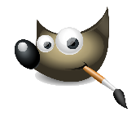1.5.1 GIMP 16

1.5.1a Screenshots 16

1.5.1b Features 17

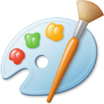1.5.2 Microsoft Paint 18

1.5.2a Screenshots 18

1.5.2b Features 19

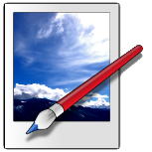1.5.3 Paint.NET 20

1.5.3a Screenshots 20

1.5.3b Features 21

1.5.4 Comparison of packages 22

1.5.5 Conclusions 23

1.5.5a GIMP 23

1.5.5b Paint 23

1.5.5c Limitations 23

1.6 Software and hardware requirements 24

1.6.1 Software 24

1.6.2 Hardware 24

1.6.2a Input 24

1.6.2b Processing 24

1.6.2c Output 24

1.6.2d Storage 24

1.7 Justification of features 25

1.7.1a Brushes 25

1.7.1b Other image editing tools 25

1.7.1c File system support 25

1.7.2 Limitations 25

1.7.2a Brushes 25

1.7.2b Other image editing tools 26

1.8 Success Criteria 27

**Feature** 27

**Proof** 27

**Code** 27

Section A - Brushes 27

Section B – Other editing tools 27

Section C – File System 28

Section D – Usability 28

1.9 Project Plan 29

1. Analysis

# 1.1 The task

The task is to create a painting program for a Windows PC, which allows users to create images, and then save and share them.

The program will feature:

* Brushes
* Other area filling tools
* Layer system
* Saving and loading files
* Importing and exporting images

The program would be suitable for a computer due to:

* A computer can save editing history, allowing for easy undoing of errors. Doing this in real life either requires an eraser (which can be messy) or is impossible.
* The mouse pointer allows precise locations to be selected quickly, and many points can be quickly inputted using the mouse
* Computational methods allow problems impractical with pens are solvable using a computing algorithms, such as filling an area, replacing a colour and creating a gradient
* Files can be saved and shared electronically, and quickly duplicated. This makes it easier and faster to share with users
* The keyboard allows text to be entered and manipulated quickly, often faster than by handwriting

# 1.2 Stakeholders

I have approached a small group of Stakeholders. They are students who use art programs often, such as art students, and other frequent art creators. They have agreed to provide feedback and help suggest features for the program.

Other people who may use the program are:

* Other graphical design students
* People wanting to make simple image edits
* Younger users who may be overwhelmed with more complicated image editing packages
* Those not wanting to make physical images

The painting program will be suitable for them as they all use computers and have an interest in creating images.

The program will result in digital images that can be easily shared, which is a value to the stakeholders as they primarily create digital art.

## Stakeholder profiles

**Name:** Alex G

**Art Background:** Uses GIMP primarily to create small web comics from scratch, using a variety of pen and fill tools.

**Would benefit from:** Tools for pens, fill tool, image exporting into formats, fast speed.

**Name:** Alex H

**Art Background:** Uses Paint to make small edits to existing images, does not need advanced features, just an easy-to-use package.

**Would benefit from:** Image importing and exporting, simple GUI, commonly use tools are easy to select

**Name:** Dheshpreet

**Art Background:** Uses a high end graphics creation tool to create large and detailed images, for an art qualification.

**Would benefit from:** More advanced tools, and support for larger images.

# 1.3 Computational Justification

The problems lends itself to computational methods very well as:

* There is a large amount of scope for **decomposition**. After the initial groundwork is set (setting pixels, resizing and displaying the image), most additional features can be built interdependently on top of the framework. This relies on a good and consistent level of **abstraction**, so that I am able to come back to previous classes and interact with them in an intuitive way.
* Because of these features **divide and conquer** can be implemented and so each tool can be worked on independent of any other, and then linked together on a GUI at project completion
* Areas for **abstraction** are:
  + The display can be abstracted into a two dimensional board of ‘pixels’, squares containing a single colour.
  + The picture will completely composed of these squares, no other shape will be possible
  + The brushes will be abstracted as methods to set these pixels in certain patterns.
  + All brushes and tools will have infinite ‘paint’, it is impossible to run out of a colour
  + All brushes and tools will be instantaneous, they will complete their task as fast as computationally possible
  + Paint will be abstracted to an RGB standard colour. The 3-byte standard does not cover every colour combination possible in the real world but will have a large enough colour depth for this program.
* The problem can be largely decomposed into these sections:

## Abstraction Diagram

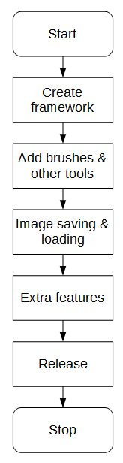

Start of the project.

The internals of the software need to be initially created, involving features for setting pixels, creating an image and displaying it consistently.

The extra brushes and tools need to be added on top of the original framework. It should be noted to be preferable to, after the framework is finished it should need to be reliable and functional enough to not need to be edited at any other point in development

After images can be created, there need to be ways to bring them in and out of the program, either using popular image formats or a proprietary format for the program.

Any extra features that have been requested by the stakeholders can now be added (time permitting), however there will not be feature creep (features being added for the sake of being added), any added features will serve a purpose

Program is released to the stakeholders for open testing and formal feedback (whilst small prototypes would be released throughout development). Any minor tweaks and fixes can be added now.

Work ceases.

# 1.4 Interview

## 1.4.1 Question Plan for online form

These questions will be used for an online form (likely using Google Forms) that will be sent to a large selection of students in my class. They are all competent computer users who will have had experience in creating images in the past, so should help provide some valuable feedback.

### 1.4.1a Questions:

#### Question 1: What main features are you looking for in an image editing program?

This question as intentionally very broad. This is provide initial pointers on what is a good decision for the program.

#### Question 2: What brushes (or other drawing tools) do you commonly use to create content? when creating an image and what are their important features?

This question is here to get an understanding of what tools are commonly used when the user edits an image. This is to get a feeling of what tools are most direly needed, and cannot be missed.

#### Question 3: What other tools in your image editing program do you commonly use when editing images, and what are their important features?

This question focuses less on the brushes and more on other image editing tools, such as layering or resizing of sections, to help gain other responses independent of the second question.

#### Question 4: What image editing program(s) do you currently use?

This question is here to get an understanding of what programs are already in use, so that they can be researched to find out what makes them so effective and popular.

#### Question 5: What image formats do you commonly use? (png, jpeg) Please put them in order of most used to least used.

This question is here to get an understanding of what images formats are wanted, so that they can be both imported and exported in the final program.

#### Question 6: What do you use image editing programs for?

This question is here to get an understanding of what the purpose of their image editing is. This can help inform me when making decisions as to what features should be prioritized.

### 1.4.1b Responses:

The survey received seven responses from potential users, the feedback will be summarized here:

#### Question 1: What main features are you looking for in an image editing program?

There were many varying responses to this question, including:

* Speed
* Copying and Pasting tools
* Cropping images
* Text
* Layers
* Exporting and Importing images

#### Question 2: What brushes (or other drawing tools) do you commonly use to create content?

There were also a large amount of responses to this question, including:

* Straight line tools
* Magic select
* Eraser
* Fill (bucket) tool
* Hard pencil
* Soft brush

#### Question 3: What other tools in your image editing program do you commonly use when editing images, and what are their important features?

There was a large amount of image editing programs used, so many different features were suggested, including:

* Crop
* Marquee
* Image thumbnail display
* Changing visibility for certain layers

#### Question 4: What image editing program(s) do you currently use?

As stated above, many programs are in use, which are summarized in this pie chart:

From this diagram it becomes clear that the default Microsoft packages (Paint & Paint 3D) are the most popular ones, with GIMP coming in third place and the more powerful packages (Krita & Photoshop) less in use.

#### Question 5: What image formats do you commonly use? (png, jpeg) Please put them in order of most used to least used.

The split between which was the primary image format is split between png and jpeg, with first place priority given as follows:

This shows that there is a much higher demand for PNG images over JPEG images, so they should be prioritized during implementation. JPEG remained very popular however, almost always placing second where it did not place first.

Other image formats suggested were GIF, BMP and ICO.

#### Question 6: What do you use image editing programs for?

It became clear that many used image manipulation programs for very simple image edits (for ‘memes’), whilst overs used it for creating original artworks. It is clear that the user base is split between editing and creating, so there should be features to cater for both.

### 1.4.1c Conclusion

From this market research it is clear that there is a lot of difference in opinion on necessary features for the program. The main pieces of advice from the market research is that:

* The requested tools are:
  + Copying and Pasting tools
  + Cropping images
  + Text
  + Layers
  + Changing visibility for certain layers
  + Exporting and Importing images
  + Straight line tools
  + Magic select
  + Eraser
  + Fill (bucket) tool
  + Hard pencil
  + Soft brush
  + Crop
  + Marquee
  + Image thumbnail display
* Paint and Paint 3D are the most commonly used image editing programs, so cues from them are the most valuable.
* PNG and JPEG formats are the most widely in use.

## 1.4.2 One-to-One interviews

These interviews will be conducted with a very small and select group of art program users. After completing the larger online form interviews, I now have an idea of what is being looked for. I will ask follow on questions from the responses given.

### Stakeholder A – Alex G

**Name:** Alex G

**Art Background:** Uses GIMP primarily to create small web comics from scratch, using a variety of pen and fill tools.

**Would benefit from:** Tools for pens, fill tool, image exporting into formats, fast speed.

#### Question 1: What main features are you looking for in an image editing program?

“I am looking for a dark mode, potential dock-able windows, layer tools and exporting transparent PNGs.”

#### Question 2: What brushes (or other drawing tools) do you commonly use to create content?

“I mainly use the hard pencil tool when making images, and I like that you can exactly specify the brush size, which you cannot do in paint.”

#### Question 3: What other tools in your image editing program do you commonly use when editing images, and what are their important features?

“I use the control key + scroll a lot to zoom in and out of the image.”

#### Question 4: What image editing program(s) do you currently use?

“GIMP”

#### Question 5: What image formats do you commonly use? (png, jpeg) Please put them in order of most used to least used.

“Mostly large PNGs.”

#### Question 6: What do you use image editing programs for?

“I use GIMP to draw comics for an online audiences, which are large drawings made completely from scratch.”

#### Question 7: What features do you use less often?

“I don’t often use the smudge tool.”

### Stakeholder B – Alex H

**Name:** Alex H

**Art Background:** Uses Paint to make small edits to existing images, does not need advanced features, just an easy-to-use package.

**Would benefit from:** Image importing and exporting, simple GUI, commonly use tools are easy to select

#### Question 1: What main features are you looking for in an image editing program?

“In editing images, I often use copy and paste, brushes, fill tool, text is a must, and layers. I also like those artistic effects from Microsoft Word, such as grayscale and sepia.”

#### Question 2: What brushes (or other drawing tools) do you commonly use to create content?

“I often use the brushes for large areas, and the finer single pixel pencil tool for fine work. I also use the Fill and a Rubber. Often I want to reuse a colour, so I would also like an eyedropper tool.”

#### Question 3: What other tools in your image editing program do you commonly use when editing images, and what are their important features?

“I’ve used in the past the Blur tool, which averages the colour between two areas. I would also like to be able to resize images, and rotate them. I would expect rotations of 90° but would like to be able to rotate around a full 360°.

In terms of the colour picker, I would like it to allow me RGB input, as I often get colours from online. Also it would be good if it would save colours I’ve used temporarily, but they don’t need to be stored with the actual art piece. A basic set of colours to use would also be good.”

#### Question 4: What image editing program(s) do you currently use?

“I mostly used Paint and Paint 3D. I sometimes use piskel for making small sprites for games, and have used GIMP & Inkscape in the past.”

#### Question 5: What image formats do you commonly use? (png, jpeg) Please put them in order of most used to least used.

“Mainly PNG or JPEG, what the default is. I’ve also sometimes used GIFs for animation.”

#### Question 6: What do you use image editing programs for?

“I’ve recently used image editing programs for my Geography coursework, where I labelled routes on an existing map, created a ‘North’ arrow, and added a ‘scale’.”

### Stakeholder C – Dheshpreet

**Name:** Dheshpreet

**Art Background:** Uses a high end graphics creation tool to create large and detailed images, for an art qualification.

**Would benefit from:** More advanced tools, and support for larger images.

#### Question 1: What main features are you looking for in an image editing program?

“I’m looking for a good selection of brushes, especially hard brushes, a blending tool, a good fill tool, and drawing tablet compatibility, as it’s what I often use. Also I’d like to see layers, and clipping masks”

#### Question 2: What image editing program do you most often use?

“Krita”

#### Question 3: What do you like about Krita?

“It’s easy to use, supports graphics tablets and has lots of advanced tools”

#### Question 4: What do you use image editing programs for?

“Mostly drawing images, or fixing up physical drawings.”

#### Question 5: So you’d need to be able to import / export images?

“Yeah, mostly PNG and JPEG”

# 1.5 Existing solution research

There are many existing image manipulation packages available. I will research the features of a variety of these and tabulate the main features of them.

The plan for research cover these headings:

* Program type (open source, free etc)
* GUI and main features (with annotated screenshot)
* Table of features.

The tables of features will be combined in the end, and will include whether this feature will be included in the painting program with a justification of why.

## Image result for gimp1.5.1 GIMP

GIMP, (GNU Image Manipulation Program) is an open source image manipulation package for Windows, Linux and Mac. It is free to download and view its source code.

The version being viewed is GIMP 2.10

### 1.5.1a Screenshots

Toolbox

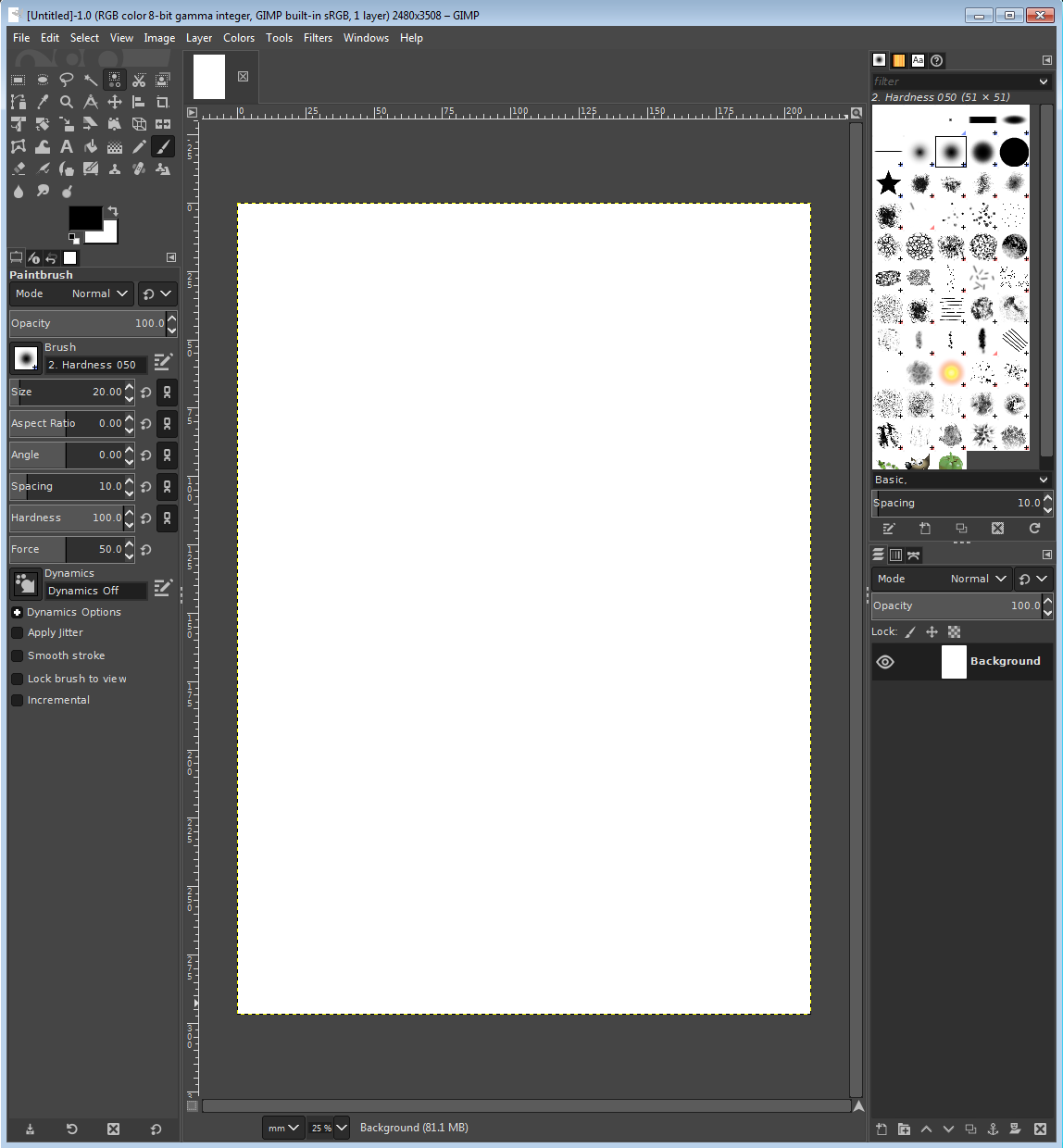

Colour

Picker

Brush

Properties

Picture display

Layer Selector

Sel

*A screenshot taken showing GIMP 2.10*

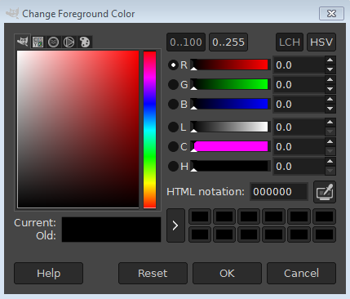

*The RGB picker from GIMP.*

### 1.5.1b Features

|  |  |
| --- | --- |
| **Feature** | **Description** |
| Rectangle Selection Tool | Allows a rectangle to be selected on the image, to be manipulated |
| Magic Selection Tool | Selects a region based on similar colours, used for quickly selecting an object with a complex border |
| RGB Selector | RGB Selector for selecting a colour quickly and accurately. A square shows the available shades of a colour whilst a range of colours is shown off to the side |
| Colour Picker | Allows you to select an existing colour on your image to use again |
| RGB exact input | Allows you to enter an exact colour using standard notation for example #FF0000 |
| Soft brush | A brush with softer edges for the document |
| Hard brush | A brush with completely sharp edges filling solid colour |
| Brush size manipulation | The brush’s size can be changed from 1 pixel across to many circles |
| Layer tools | Layers can be hidden, shown and changed in order. Each layer is a separate drawing |
| Transparency support | Pixels can have varying levels of opacity. |
| Supported image formats | Supports nearly all major image formats, with extension support for obscure ones |
| Zoom | Images can be zoomed very freely, to fill the screen |
| On-screen ruler | A sense of scale can be gained using an on-screen ruler |
| History Viewer | No support |

## 1.5.2 Microsoft Paint

Colour Picker

Toolbox

### 1.5.2a Screenshots

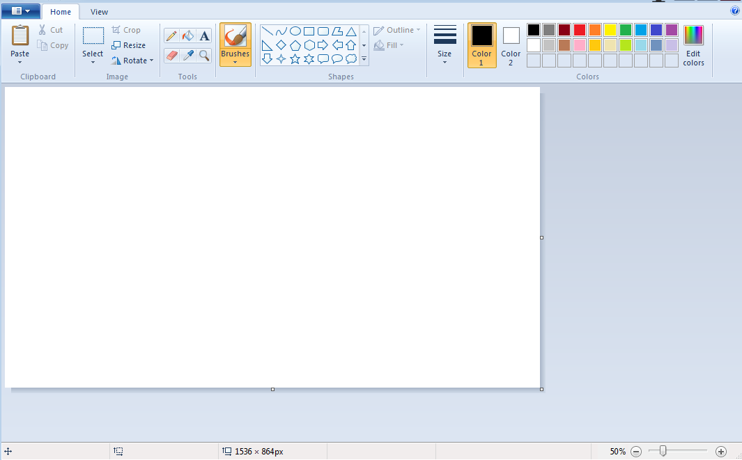

Page Display

*A screenshot taken showing Paint.*

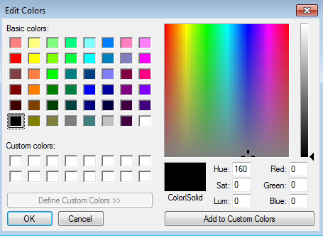

*The RGB picker from Paint.*

### 1.5.2b Features

|  |  |
| --- | --- |
| **Feature** | **Description** |
| Rectangle Selection Tool | Allows a rectangle to be selected on the image, to be manipulated |
| Magic Selection Tool | Not available. |
| RGB Selector | RGB Selector for selecting a colour quickly and accurately. A square shows the available colours whilst a range of shades is shown off to the side |
| Colour Picker | Available, but not in the colour selection menu |
| RGB exact input | Available, but is more finicky as involves three smaller number boxes, does not support standard formats |
| Soft brush | A brush with softer edges for the document |
| Hard brush | A brush with completely sharp edges filling solid colour |
| Brush size manipulation | The brush’s size can be changed to a number of pre-sets, however only 6 settings are available |
| Layer tools | No support |
| Transparency support | No support |
| Supported image formats | Supports png, bmp, gif, jpeg |
| Zoom | Images can be zoomed to intervals of 25%, to a max of 200%. Not very free |
| On-screen ruler | No support |
| History Viewer | No support |

## Image result for paint.net logo1.5.3 Paint.NET

### 1.5.3a Screenshots

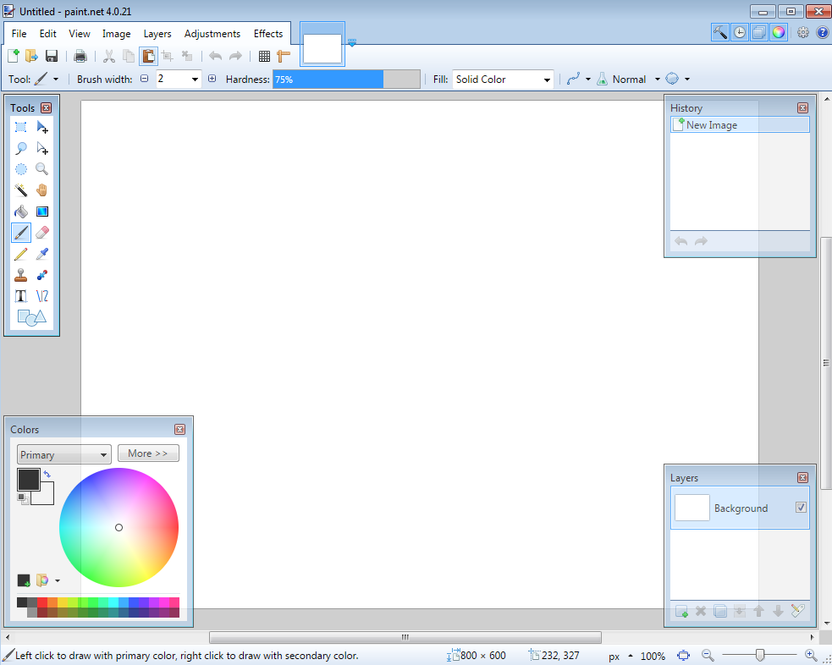

Page View

History

Viewer

Layer

Tool

Colour

Picker

Toolbox

### 1.5.3b Features

|  |  |
| --- | --- |
| **Feature** | **Description** |
| Rectangle Selection Tool | Allows a rectangle to be selected on the image, to be manipulated |
| Magic Selection Tool | Available |
| RGB Selector | RGB Selector for selecting a colour quickly and accurately. A square shows the available shades of a colour whilst a range of colours is shown off to the side |
| Colour Picker | Allows you to select an existing colour on your image to use again |
| RGB exact input | Allows you to enter an exact colour using standard notation for example #FF0000 |
| Soft brush | A brush with softer edges for the document |
| Hard brush | A brush with completely sharp edges filling solid colour |
| Brush size manipulation | The brush’s size can be changed from 1 pixel across to many circles |
| Layer tools | Layers can be hidden, shown and changed in order. Each layer is a separate drawing |
| Transparency support | Pixels can have varying levels of opacity. |
| Supported image formats | Supports nearly all major image formats, with extension support for obscure ones |
| Zoom | Images can be zoomed very freely, to fill the screen |
| On-screen ruler | Not available |
| History Viewer | Shows a list of the user’s previous actions, allows them to navigate and undo certain actions in a user friendly way |

## 1.5.4 Comparison of packages

|  |  |  |  |  |
| --- | --- | --- | --- | --- |
| **Feature** | **GIMP** | **Paint** | Paint.NET | **Conclusions & Application** |
| Rectangle Selection Tool | ✓ | ✓ | ✓ | The program should include a rectangular selection tool, as it is simple to program and is included in all researched art creation programs |
| Magic Selection Tool | ✓ | ✗ | ✓ | The program should include some sort of magic selection tool, as many art creation programs utilise it in some form. |
| RGB Selector | ✓ | ✓ | ✓ | The RGB selector should include a tray for recently used colours, as all three of the analysed programs had some sort of previous colour feature |
| Colour Picker | ✓ | ✓ | ✓ | The RGB selector is very important to the program, and the design should be considered. GIMP uses a square of shades, Paint uses a square of colours, Paint.NET uses a circular colour selector with limited support for shades.  The program should make sure that a specific colour can be quickly selected, and its shade changed. |
| RGB exact input | ✓ | ✗ | ✓ | RGB should be able to be exactly entered in order with the standard format #RRGGBB |
| Soft brush | ✓ | ✓ | ✓ | A rudimentary form of soft brush is often used in art programs |
| Hard brush | ✓ | ✓ | ✓ | A hard brush is very simple to create and should be in the program |
| Brush size manipulation | ✓ | ✗ | ✓ | Whilst Paint does not include a brush width editing feature, the other two packages do and it is more useful to be able to fine-tune the width |
| Layer tools | ✓ | ✗ | ✓ | This is also a feature missing from the more basic Paint, but is necessary for complex picture creation |
| Transparency support | ✓ | ✗ | ✓ | This is also a feature missing from the more basic Paint, but is necessary for complex picture creation |
| Supported image formats | Many | Few | Few | GIMP supports a wider range of image formats than the other packages, however in practical use the fewer formats provided by Paint and Paint.NET are needed. |
| Zoom | ✓ | ✓ | ✓ | Whilst all packages contain a zoom, they come in varying levels of freedom of zoom. Paint has a very limited degree of freedom, whilst GIMP allows almost any level of zoom. This means that there should at least be the same level of zoom as Paint. |
| On-screen ruler | ✓ | ✗ | ✗ | This is shown to be a rather niche feature, being only included in GIMP, meaning that it is likely that there is low demand for this feature, so it is not needed. |
| History Viewer | ✗ | ✗ | ✓ | This is also shown to be very niche, and the rest of the programs suffice with a simple Undo tool rather than an entire window |

## 1.5.5 Conclusions

From this research I can conclude that, as I found from my market research, Paint is the most applicable package to draw inspiration from for the program. It is the most commonly used program by my stakeholders, and as a proprietary Microsoft product packaged with Windows, its features will have been well considered by a large team.

Features that I will utilise from each package:

### 1.5.5a GIMP

The layer system from GIMP will be utilised, as it is the most commonly used program to utilise layers. Other layer features such as hiding and showing layers will also be included.

The GUI however is quite complex, containing a lot of options & additional features, so the GUI from GIM would not be appropriate for this program, which will include comparatively fewer features, so does not need a complex GUI

Other features lifted from GIMP will be many of its brush and editing tools, and its support for transparency.

### 1.5.5b Paint

From Paint, features such as its shape tool will be included, as well as its implementation for inputting text.

A lot of inspiration will be taken from the GUI, as Paint contains relatively fewer tools than the other packages, so it has a good layout for few total options. This helps improve clarity and speed of operations as most features can be seen by the user without having to search menus.

### 1.5.5c Limitations

The final product will be limited however as it will not be using some features from the research, such as not showing history of operations, making reverting actions more difficult, and it will likely not support many file formats (only JPEG, PNG) due to the large amount of work needed to research and implement other image formats, making it not worth the time.

# 1.6 Software and hardware requirements

## 1.6.1 Software

The program will require a Windows computer, to run the software on. Other operating systems will not be able to run the program, as they are largely incompatible and will require a re-write for each system, which is a lot more development.

The program will need up-to-date and standard drivers for all its relevant hardware, so that the hardware can communicate effectively with the program.

## 1.6.2 Hardware

### 1.6.2a Input

The program will require a mouse or similar pointing device, to enter on-screen locations to draw the image or select points for editing, and for clicking at certain times to perform actions quickly.

The program will require a keyboard, for inputting text in a text drawing tool. As most of the stakeholders interviewed use a desktop computer for editing images, there should also be good key shortcut support in the program for those users who want to access those features quickly.

### 1.6.2b Processing

The program will need a computer capable of running the Windows operating system, this is because the Windows operating system is a required base for the program

The program will need around 100MB of available RAM. This is so that it can hold the current image data in RAM, which may be quite large depending on the image size. The user will not want to run out of available RAM when using the program, and have to either use virtual memory (making image edits significantly slower) or having the program crash and potentially lose data.

### 1.6.2c Output

The program will need a standard display output device, likely a monitor or projector, which can connect to the computer using a standard driver & Windows protocol. As long as the Windows operating system can display to the output device, so can the program.

The program will **not** need any sort of audio output device, as there is no point where sound will be necessary for its operation (it edits images). To make the program more accessible to the stakeholders who do not use speakers very often or do not have them, this output device will not be included.

### 1.6.2d Storage

The computer will need a small amount of storage for the program, and its files. Whilst the executable itself is not likely to be very large, some of the larger image files will require more storage space. To help alleviate this, a small amount of lossless compression will be applied to the images, to help reduce the amount of storage needed.

# 1.7 Justification of features

### 1.7.1a Brushes

* Variable brush width
* Hard brushes
* Shape creation tools
* Fill (bucket) tool
* Single pixel pencil
* Rubber

### 1.7.1b Other image editing tools

* Bitmap image editor.
* RGB Colour picker
  + Based on the Microsoft Paint colour picker design
  + Allows direct RGB input
* Layer system
* Rectangle selection tool
* Magic selection tool
* Partial transparency support
  + There will be support for completely blank tiles (empty), for use with layers.
* Zoom in
* Text
* Image effects
* Eyedropper
* Rotating images through 90°
* Clipping masks

### 1.7.1c File system support

* Importing images of supported formats
* Exporting images of supported formats
* Supported image formats
  + PNG
  + JPEG
* Saving a proprietary format containing extra information about layers and other metadata.

## 1.7.2 Limitations

The program will **not** contain these features:

### 1.7.2a Brushes

* Soft brushes
  + Whilst brushes with a hard edge only involve a simple set of pixel colour, soft edged brushes have a much larger level of complexity. This is due to the need for colour mixing, where the edges of the brush will need to ‘blend’ into the surrounding colour, the calculations for which are out of the scope of the timing of the project.
  + The reasoning for this is covered in more depth at ‘Other image editing tools’ -> ‘Full transparency support’
* Large amount of shapes
  + This is to cut down on the amount of redundant code in the project. It may be possible to program an extensive list of shapes into the program, however this would be a lot of redundant coding work for shapes that may not be used often.
* Fast fill
  + The fill function is an example of where the algorithm makes a large impact on the time taken to complete the action. As with sorting, there are many algorithms for filling an area, with varying complexity. To cut down on time & complexity, and as most edited images will likely not be large to begin with, only a simple filling algorithm will be implemented.

### 1.7.2b Other image editing tools

* On-screen ruler
  + From the product research, it became clear than an on-screen ruler was a niche feature, not always necessary to be included in software packages
* History viewer
  + Similar to the On-screen ruler, the history viewer also had a smaller usage in market.
* Full transparency support
  + Whilst there will be support for fully transparent pixels (on layers), there will not be support for partially transparent pixels. (pixels with opacity). This is due to the complexity of the algorithms that determine the resultant colour of pixels, especially with multiple semi-transparent pixels combined together. There must be some degree of transparency in the program, or else the layer system would be useless, so this is a fair compromise between features and complexity.
  + It is for this reason that the soft brush cannot be implemented, as the soft brush would require opacity support.
* Zooming out
  + Whilst it is necessary to provide a ‘Zoom in’ feature, it is less necessary to provide the feature to ‘Zoom out’ (e.g. view the image at 50%). In addition to this, the algorithms determining which pixels are shown when the image is reduced in size are more complicated than the algorithms for increasing in size, as decisions must be made as to which pixels are shown.
* Vector image support
  + Vector images are handled completely differently to bitmap images, and so would require a lot of time (and a completely different toolkit) to implement, so is out of the scope of this project.
* Graphics tablet support
  + Will not have any graphics tablet support, as I do not own a graphics tablet.

# 1.8 Success Criteria

The ‘code’ field denotes a shortening that will be used to refer to that criteria, for example “Criteria A1”. *Italics denote stretch goals – optional features added if there is enough time.*

|  |  |  |
| --- | --- | --- |
| **Feature** | **Proof** | **Code** |
| Section A - Brushes | | |
| Variable brush width | Screenshot of strokes of the same brush showing different widths | A1 |
| Hard brushes | Screenshot showing the hard edge of the brush (colour to no colour) | A2 |
| Shape creation tools | Screenshot showing the shape toolbar and a small selection of drawn shapes | A3 |
| Fill (bucket) tool | Screenshot showing a before and after of filling a large area | A4 |
| Single pixel pencil | Screenshot showing a stroke of the single pixel brush | A5 |
| Rubber | Screenshot showing a densely packed picture being rubbed out | A6 |
| Section B – Other editing tools | | |
| Image viewer | Screenshot of a currently being viewed image | B1 |
| Bitmap image editor | Screenshot of a zoom in on the image showing the pixels | B2 |
| RGB colour picker | Screenshot showing a system for entering an RGB colour | B3 |
| RGB direct input | Screenshot showing the user entering “FF0000” (or equivalent) and the programming outputting red | B4 |
| Layer system | Screenshot of layer navigator | B5 |
| Rectangle selection tool | Screenshot showing a rectangle selection on the image | B6 |
| Magic selection tool | Screenshot showing a complex selection around non-linear shape | B7 |
| Transparent pixels | Screenshot showing a layer with blank pixels (one layer on top of another). Partial transparency is not required | B8 |
| Zoom in (no zoom out) | Screenshot of an image at smallest zoom, followed by a screenshot at max zoom showing a portion of an image much smaller | B9 |
| Text | Screenshot of the text “Hello World” on the image | B10 |
| Eyedropper tool | Screenshot of an imported image, with the colour stroke of a colour taken from that image beneath it | B11 |
| *Image effects* | *Screenshot of an image before and after an effect is applied* | B12 |
| *Rotating Images* | *Screenshot of an image in 4 different rotations, normal, 90°, 180° and 270°* | B13 |
| *Clipping masks* | *Screenshot of an image being clipped onto a complex selection* | B14 |

|  |  |  |
| --- | --- | --- |
| Section C – File System | | |
| Creating a new image | Screenshot of a blank 300x300 square image | C1 |
| Importing images | Screenshot of the file browser showing an image preview, and screenshot showing the image in the program | C2 |
| Exporting images | Screenshot showing a custom image in the program, followed by an image showing the file browser showing the image in a folder | C3 |
| Supporting PNG and JPEG | Screenshot showing the file browser which accepts both PNG and JPEG images | C4 |
| Saving and loading from a proprietary format | Screenshot showing the user saving an image, screenshot of the image in the file browser, and the program after the image is loaded | C5 |
| Section D – Usability | | |
| Program should be stable and not crash. | A complete testing table, showing no failed tests, followed 75% yes response to asking stakeholders “Did you encounter any errors while using the program?” | D1 |
| Program should be easy to use | 75% yes response to asking stakeholders “Did you find the program easy to use?” | D2 |
| Features should be easily accessible | From the default state of the program, any feature will need to be activated by no less than 4 clicks | D3 |

# 1.9 Project Plan

Referencing the main diagram made earlier in the Analysis.



To decompose the project, each component on this diagram will be designed, coded and then tested in sequence, rather than doing all design at the start. This is to make the programming more dynamic, and show how the project builds up.